EX NO:9 E-BOOK MANAGEMENT SYSTEM
USE CASE DIAGRAM:
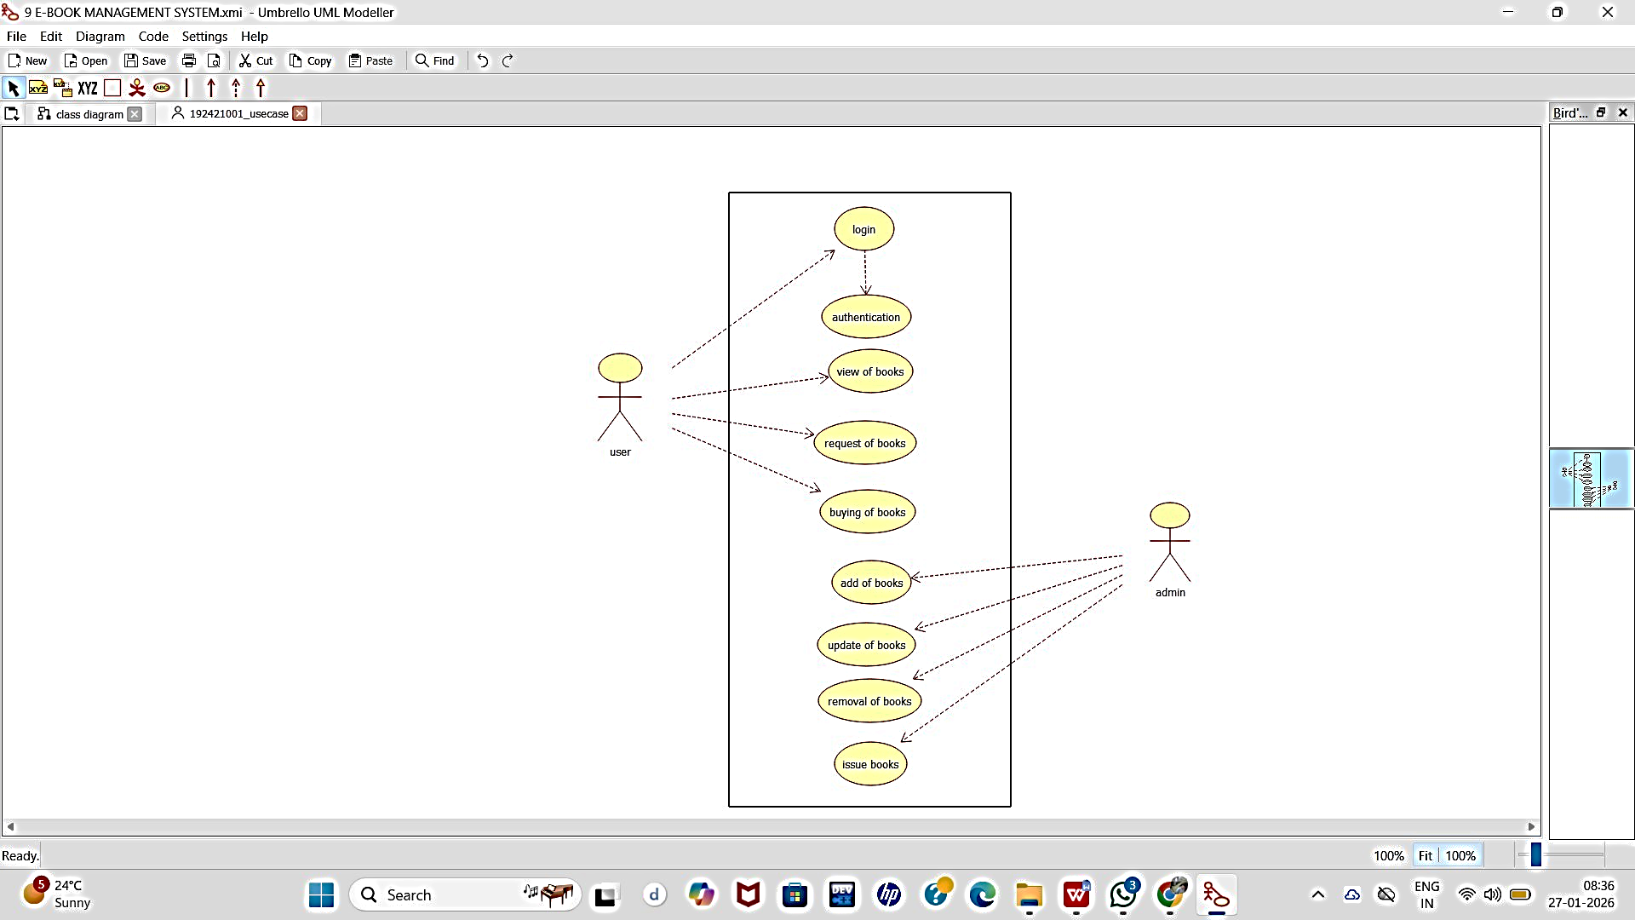

CLASS DIAGRAM:

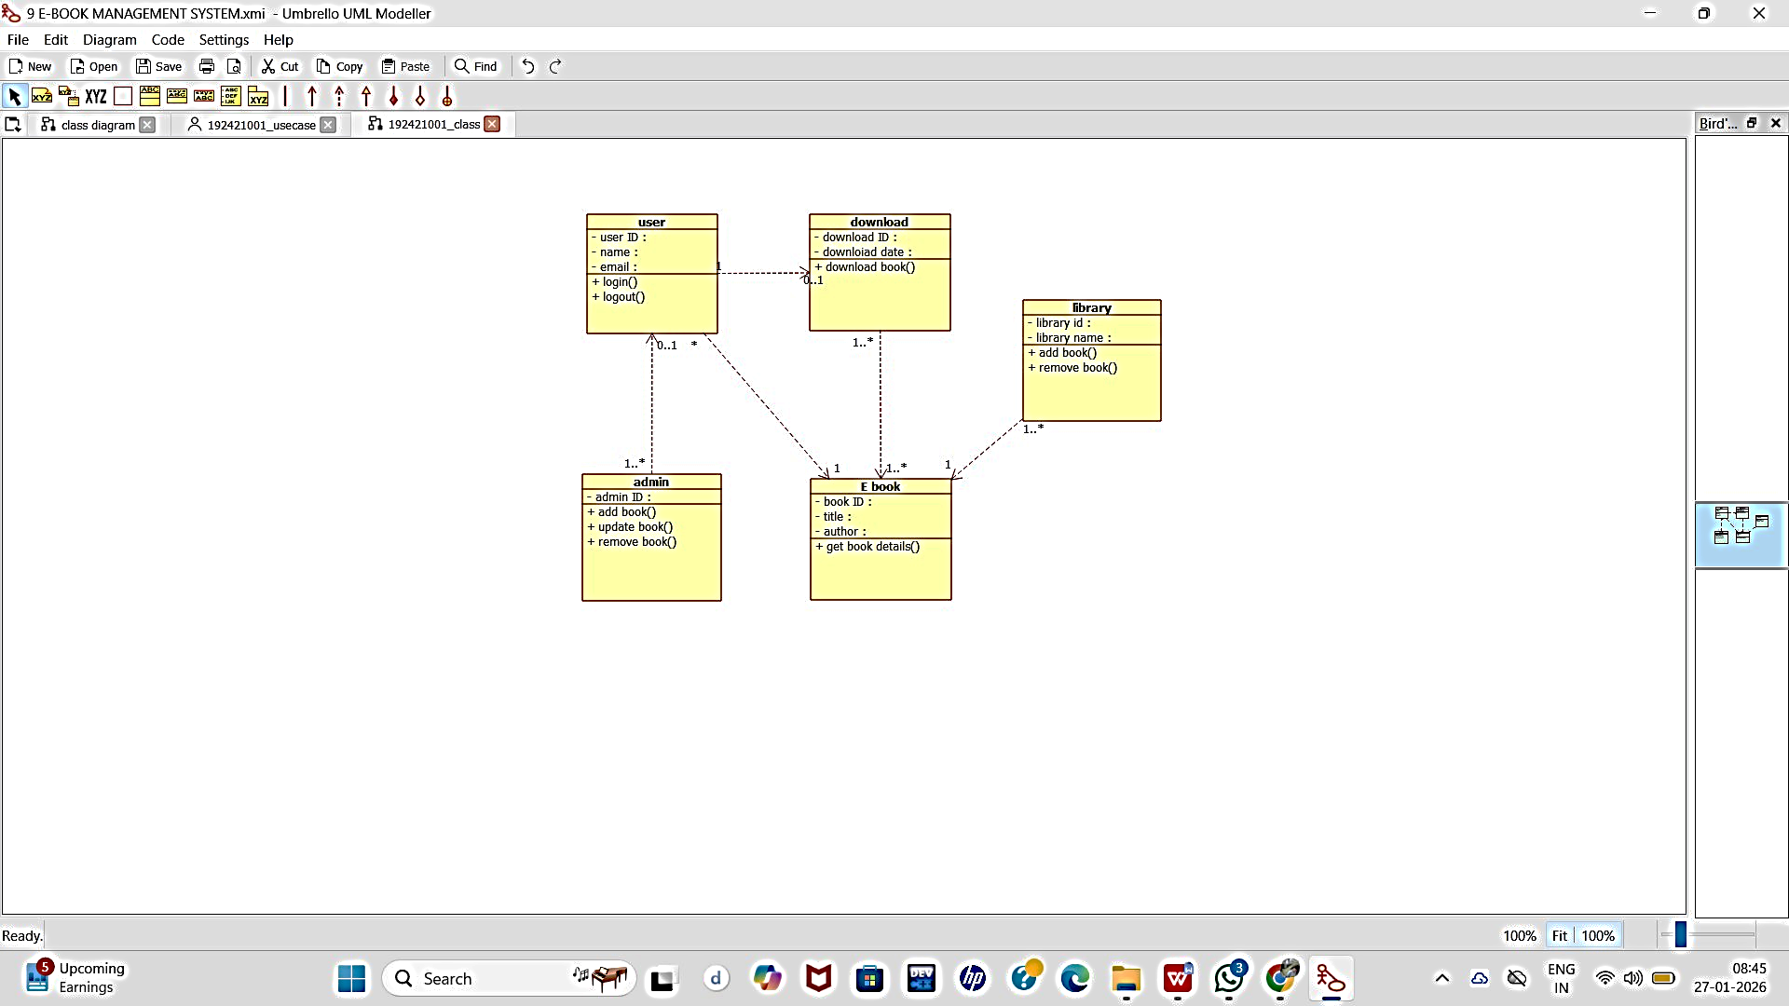

ACTIVITY DIAGRAM:

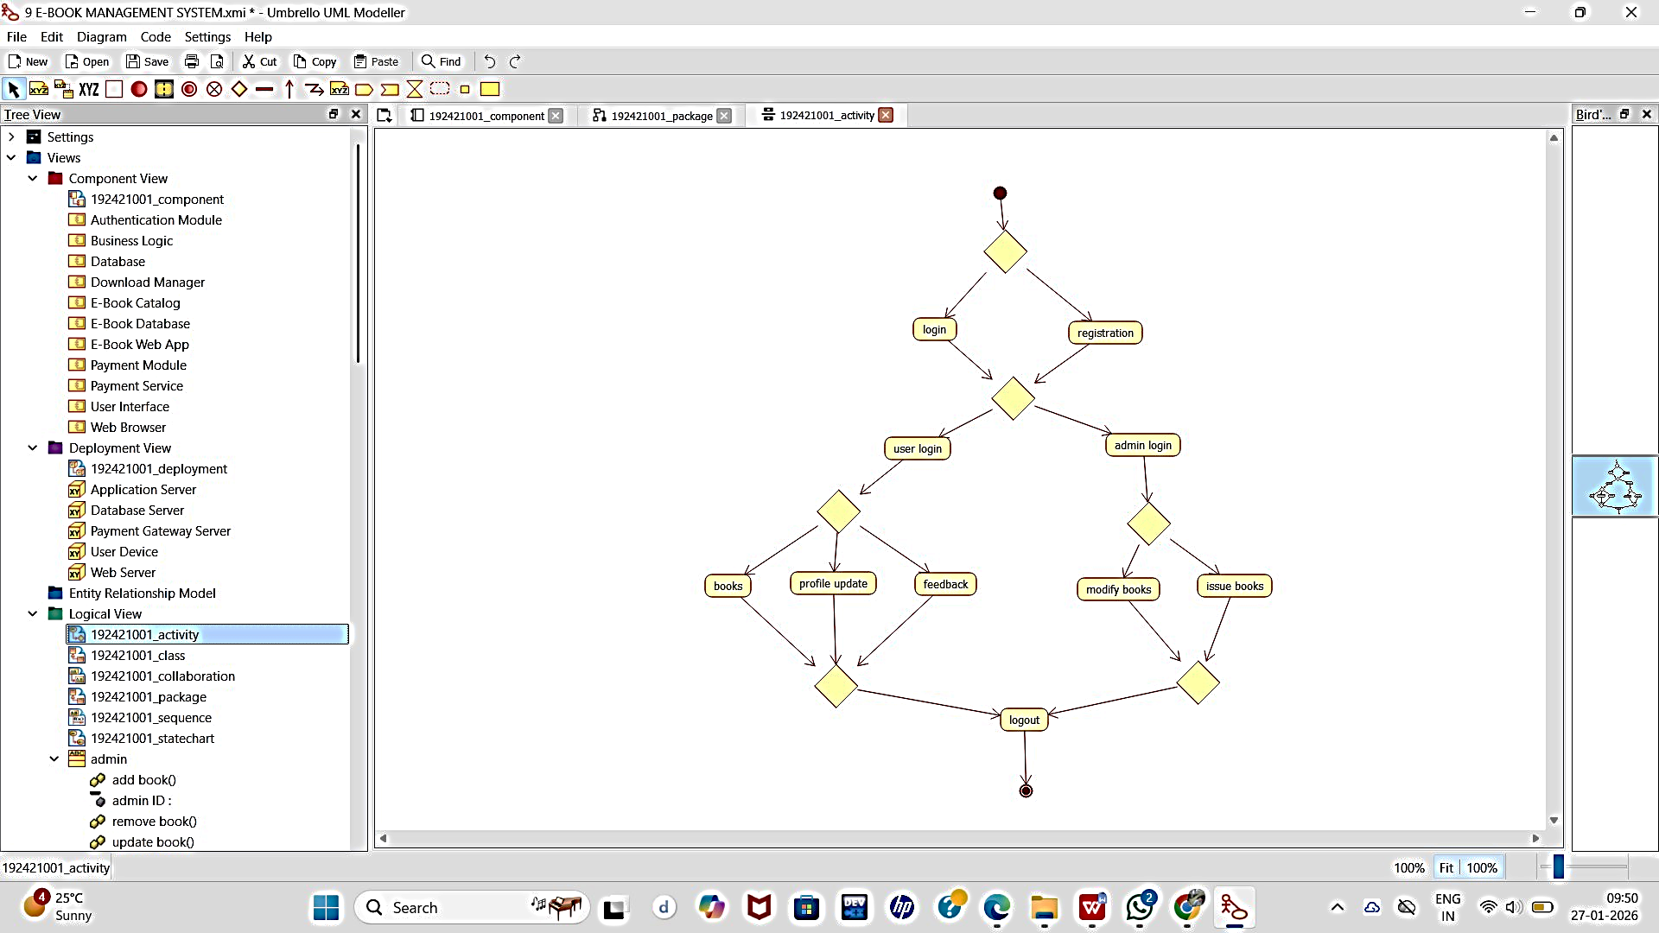

SEQUENCE DIAGRAM:

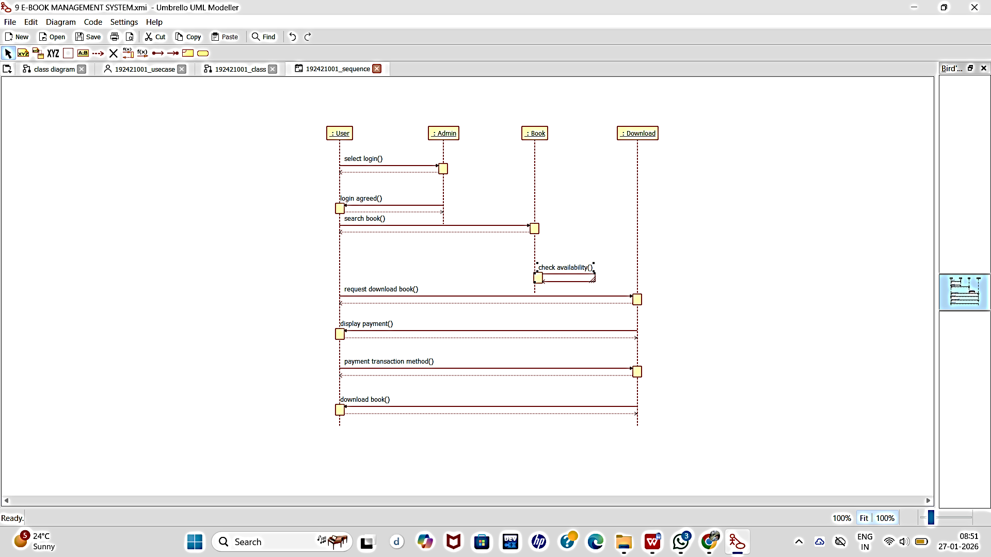

COLLABORATION DIAGRAM:

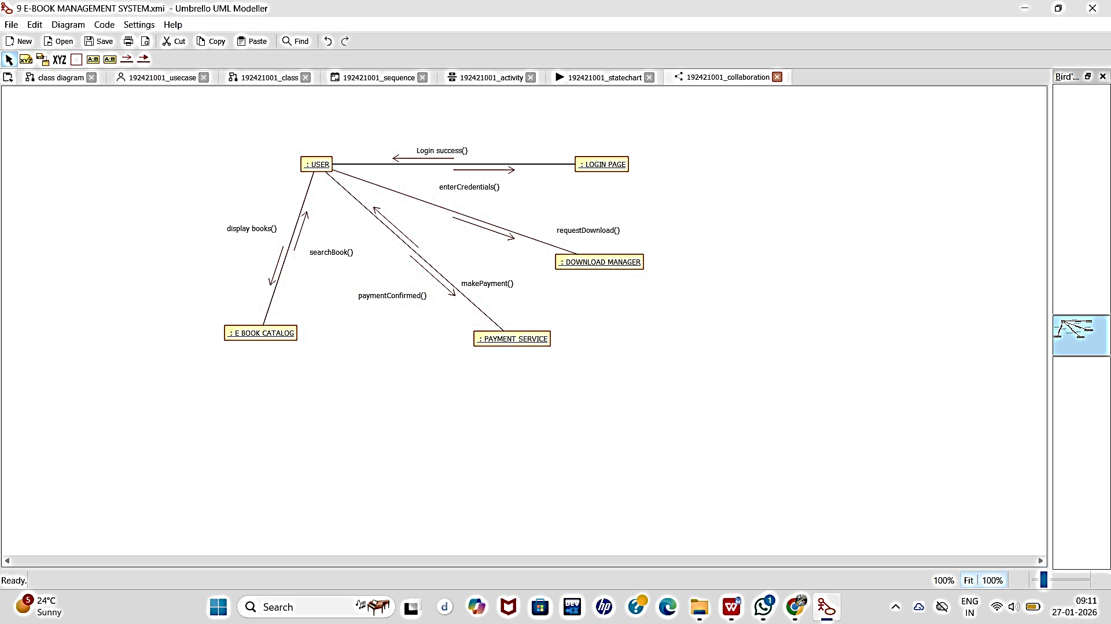

STATE CHART DIAGRAM:

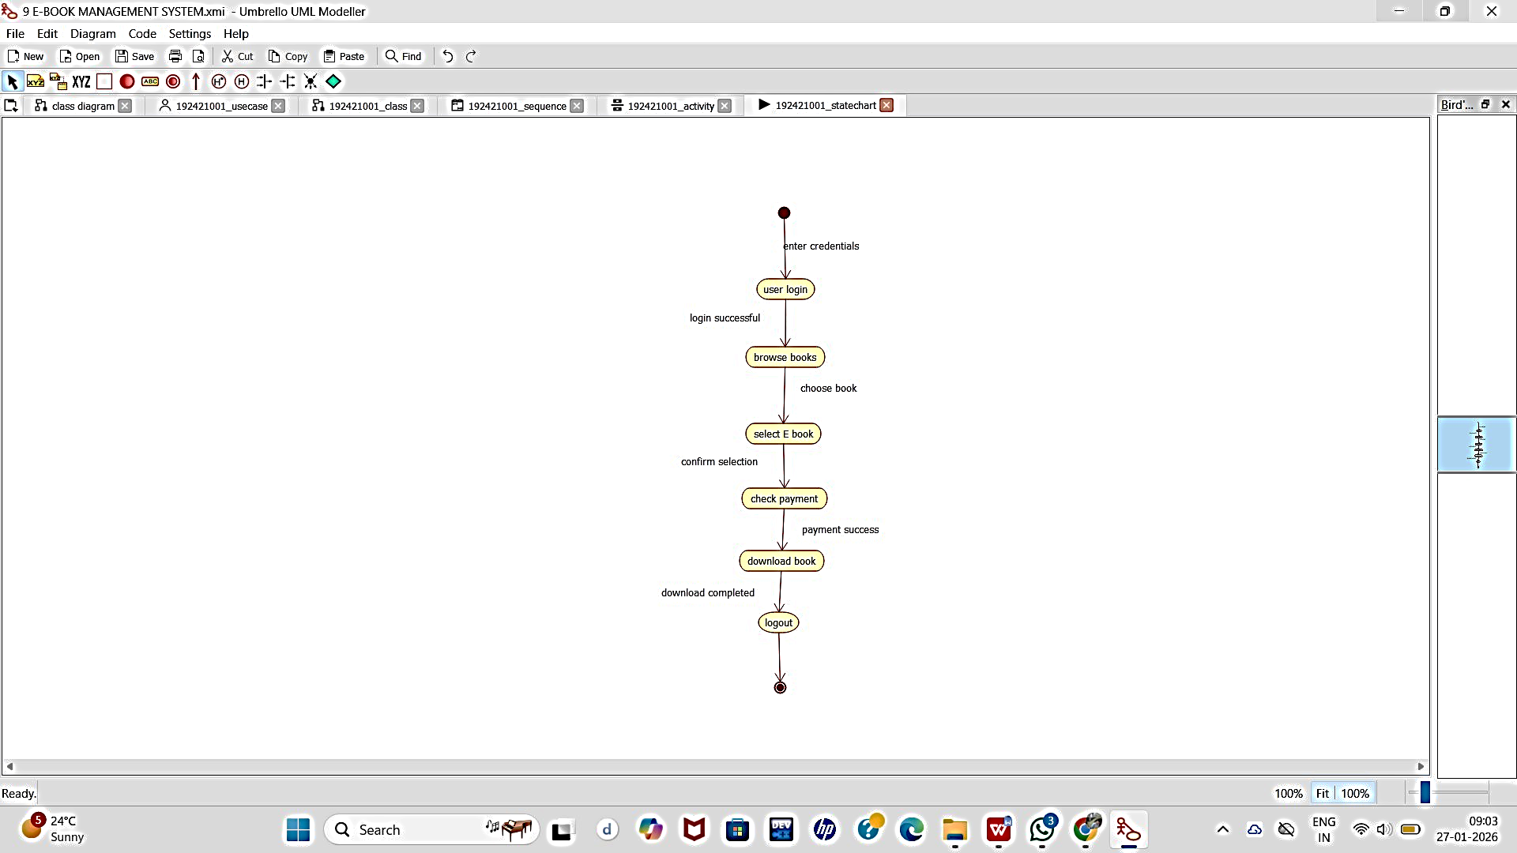

COMPONENT DIAGRAM:

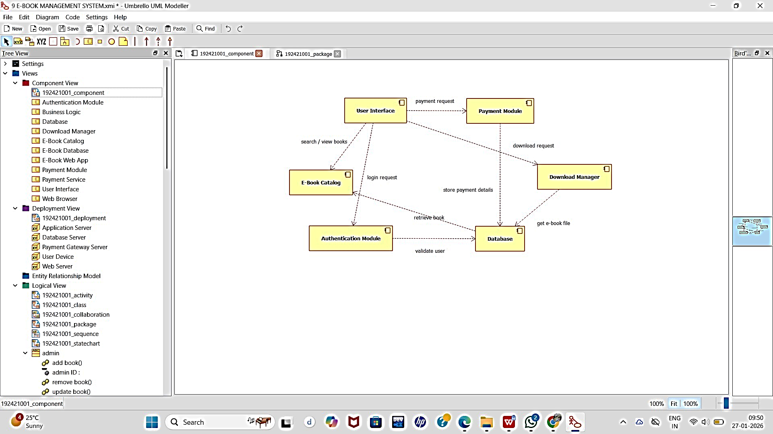

DEPOLYMENT DIAGRAM:
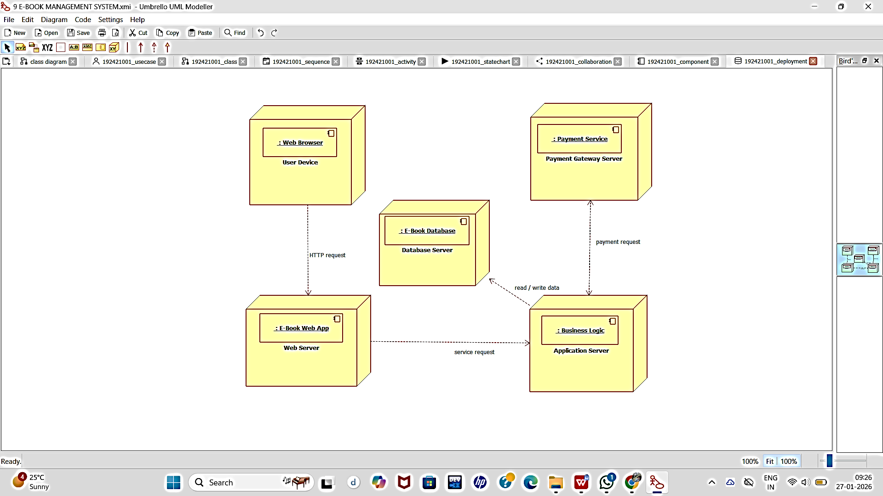

PACKAGE DIAGRAM:

